

**A project Report on**

**JUSTDAIL WEBSITE USING AUTOMATION TOOL SELENIUM WEBDRIVER WITH JAVA.**

**By**

**Surya A**

**Batch-EON (2021-5533)**

**Under the Guidance of,**

**Amurta Deore Kachole**

**(Technical Trainer)**

**EduBridge India Pvt. Ltd.**

**Introduction:**

This Project aims to do overall testing like functional testing, GUI testing on justdail website to check quality of application using selenium web driver. It helps to improve quality of website and saves time for manually doing this testing.

In this project our main focus is to test the coronahelpline Module .Corona helpline module contain the spread of novel corona virus(Covid-19) has provide these helpline number,Corona resources,Vaccination centre,Symptoms,Do and don’ts and live status of all the states.

**Software Requirements:**

Operating System: Windows 8

Browser: Latest version of Google Chrome

Platform: Eclipse IDE

Automation Tool and Language: Selenium WebDriver, Java

Files: JDK, Selenium Jar files, Common IO file

1. **C0VID-19 HELPLINE MODULE**

**TC01:** Launch the browser and justdail website

**Selenium WebDriver Test Script:**

System.*setProperty*("webdriver.chrome.driver","C:\\seleniumwebdriver\\chromedriver\\chromedriver.exe");

WebDriver driver=**new** ChromeDriver();

driver.get("https://www.justdial.com/sideMenu");

System.***out***.println("Launching website");

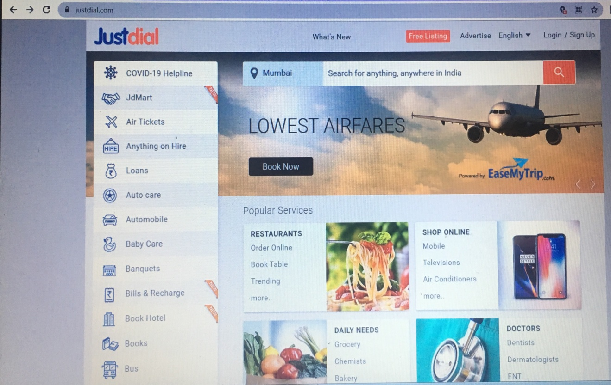

**TC02:** Maximize the window

**Selenium WebDriver Test Script:**

driver.manage().window().maximize();

System.***out***.println("Maximize the window");

**TC03:** To verify and display the covidhelpline number of all the states.

**Selenium WebDriver Test Script:**

driver.findElement(By.*xpath*("//span[@id='hotkeys_text_0']")).click(); System.***out***.println("checking covid19helplinenumber for all the states");

Thread.*sleep*(600);

JavascriptExecutorjs=(JavascriptExecutor) driver;

js.executeScript("window.scrollBy(0,1000)”);

Thread.*sleep*(2000);

System.***out***.println("Scroll down"); js.executeScript("window.scrollBy(0, -1000)");

Thread.*sleep*(2000);

System.***out***.println("Scroll up");

**TC04:** To verify and display the covid resources for particular district.

**Selenium WebDriver Test Script:**

driver.findElement(By.*xpath*("//a[contains(text(),'Covid Resources')]")).click();

System.***out***.println("Checking the covid resources");

WebElement drpdown=driver.findElement(By.*xpath*("//input[@id='citySearch']"));

drpdown.click();

driver.findElement(By.*xpath*("//*[@id=\"popularCity\"]/ul/li[6]/div[1]")).click();

System.***out***.println("Using dropdown method Searching covid resources for chennai district");

Thread.*sleep*(1000);

System.***out***.println("checking what are the covid resources are available");

**TC05:** To verify and display the covid resources of hospital beds

**Selenium WebDriver Test Script:**

driver.findElement(By.*xpath*("//body/div[@id='resources']/div[@id='category']/ul[1]/li[3]")).click();

Thread.*sleep*(5000);

js.executeScript("window.scrollBy(0, 400)");

Thread.*sleep*(2000);

js.executeScript("window.scrollBy(0, 400)");

Thread.*sleep*(2000);

js.executeScript("window.scrollBy(0, -600)");

System.***out***.println("checking for hospital beds");

**TC06:** To verify and display the vaccination centre for particular area

**Selenium WebDriver Test Script:**

driver.findElement(By.*xpath*("//a[contains(text(),'Vaccination Centers')]")).click();

System.***out***.println("Checking vaccinations centre");

driver.findElement(By.*xpath*("//a[contains(text(),'Search by Pincode')]")).click();

driver.findElement(By.*xpath*("//body/div[@id='centers']/div[1]/div[2]/div[1]/div[1]/div[1]/input[1]")).sendKeys("636010");

driver.findElement(By.*xpath*("//button[contains(text(),'Search')]")).click(); System.***out***.println("Checking vaccination centre for particular area using pincodes with the help of sendkeys"); Thread.*sleep*(5000); js.executeScript("window.scrollBy(0, 300)");

Thread.*sleep*(3000);

js.executeScript("window.scrollBy(0, 300)");

Thread.*sleep*(3000);

js.executeScript("window.scrollBy(0, -600)");

**TC07:** To verify and display the covid symptoms

**Selenium WebDriver Test Script:**

driver.findElement(By.*xpath*("//a[contains(text(),'Symptoms')]")).click();

System.***out***.println("Checking for covidsymptoms");

Thread.*sleep*(2000);

**TC08:** To verify and display the covid “do and don’ts”

**Selenium WebDriver Test Script:**

driver.findElement(By.*xpath*("//a[contains(text(),\"Do's and Don'ts\")]")).click();

System.***out***.println("Checking for do and dont's");

Thread.*sleep*(2000);

**TC09:** To verify and display the covid live status

**Selenium WebDriver Test Script:**

driver.findElement(By.*xpath*("//a[contains(text(),'Live Status')]")).click();

System.***out***.println("Checking for livestatus");

js.executeScript("window.scrollBy(0, 500)");

Thread.*sleep*(1000);

js.executeScript("window.scrollBy(0, 500)");

Thread.*sleep*(3000);

js.executeScript("window.scrollBy(0, 500)");

Thread.*sleep*(3000);

js.executeScript("window.scrollBy(0, 500)");

Thread.*sleep*(3000); js.executeScript("window.scrollBy(0, 500)");

Thread.*sleep*(3000);

js.executeScript("window.scrollBy(0, -25000)");

**TC10:** To verify the navigation go back to previous page.

**Selenium WebDriver Test Script:**

driver.navigate().back();

**TC11:** To verify that browser is able to close.

**Selenium WebDriver Test Script:**

driver.close();